Haskell Set 6, Pattern Matching
1) Write a function which accepts a String. If the String is your first name, return "First Name", if is it
your second name, return "Middle Name", if it is your last name, return "Last name", if none of the
above, return "Stranger Danger!". However, use no if statements.
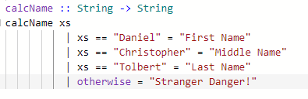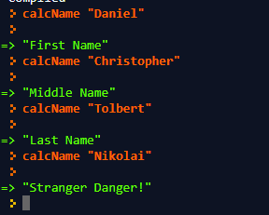
2) Write a function which accepts a tuple of three integers and returns "White", "Black", "Red", "Green",
"Blue", "A shade of Gray", "Not a color", or "(#,#,#)" if it is a color. At maximum use two if statements.
ex: colorName (255,255,255) -> "White"
colorName (3,3,3) -> "A shade of Gray"
colorName (300, 200, 500) -> "Not a color"
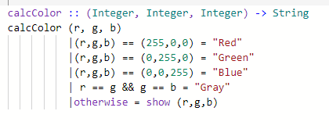
3) Write a function which accepts an integer and prints "It is decidedly so" if the int is 1, "My sources say
no" if 2, or "Ask again later" if 3. If a number other than 1,2,or 3 were to come in, what would happen?
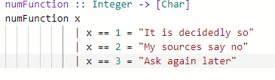
It gives the exception that:
4) Write a function that would represent a menu of choices someone might make. If they choose option
#1, return "Deposit". If they choose option #2, return "Withdraw". If they choose option #3, return "Log
out". If they choose any other option, restart the function. Write the code - but identify what is wrong
with the logic.
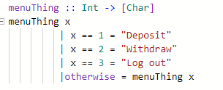
The issue with the code is that when the exception is accounted for, the function will restart with the same exact value, causing it to eternally be caught in a loop until it crashes.
5) Write a function that is used to find the average of the numbers in a list. However, generate an error
if the list has no numbers in it.
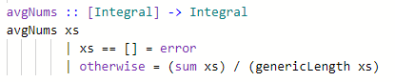
6) Write a function that given a list returns the first three elements in the list. If the list doesn't have
three elements, return only the part of the list that does exist. If the list is empty, this would return an
empty list. However, use no if statements.
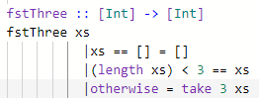
7) Write your own tail function, call it tail. It should produce an error if it is empty.
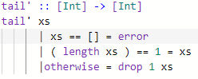
8) Write your own power function which takes an int and raises it to another int. However, don't use
any built in function other than *.
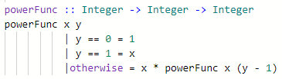
9) Rewrite the function from an earlier set that determines what grade you have in a course (90-100 = A,
80-90 = B, etcetera). If the grade is out of bounds generate "Liar" as a result.
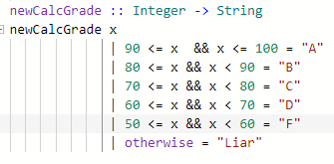
10) Write a function that given wo Strings returns "" if either String length is 0, otherwise it returns the
last char of each String attached to each other attached to the result of calling the function again on
every other letter. Use recursion.
ie: fun "" "moo" -> ""
fun "cow" "moo" -> "wo" + "oo" + "cm" -> "wooocm"
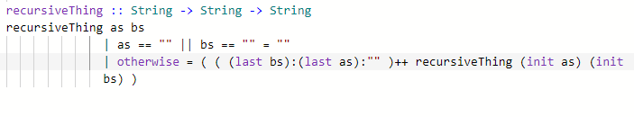
11) Write a function that determines if two coordinates ((x,y) tuples) are "Very close" to each other (less
than 1 distance), "Close" (less than 5 distance), "Somewhat near" (less than 100 distance), or "Far away"
(more than 100 distance). Don't write a separate distance function, instead, use one of the options to
build it in the function you are writing without writing the distance formula more than once.
ie: howFar (3,3) (482,300) -> "Far away"
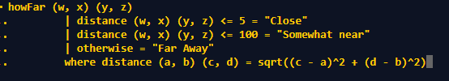
12) Write a function, without using where, to generate the initials after being given a first name and a
list name. The readings has this as a where example.
ie: initials "Thomas" "Jefferson" -> "T.J."
13) Rewrite a question from a previous set that found all triangles between two given side lengths, ie:
find all triangles from 1-3 in side lengths would check if (1,1,1), (1,1,2), (1,1,3), (1,2,1)... This time, use a
where to determine if the values themselves are a triangle.
